Guide to commissioning, in-service inspection, in-service test and frequency of testing Thermostatic Mixing Valves (TMV) for use in health and social care establishments as Type 3 valves (TMV3 approved).

Issue date: July 2012
Issue 1

Introduction
It has been recognised that users of domestic hot water for ablutionary purposes in health and social care establishments are often at risk of injury by scalding. For some time this risk has been attenuated by the use of Type 3 thermostatic mixing valves that comply with National Health Service Model Engineering Specifications D 08. Installing Type 3 thermostatic mixing valves ensures that end-users are adequately protected from the risk of scalding. The supply conditions and the valve’s performance however must be periodically monitored and the valve suitably maintained and tested to ensure that it continues to operate effectively. Changes to the temperature and pressure of the water supplies to the thermostatic valve may affect the valve’s performance and must be considered when undertaking the in-service test.
Ignoring or failing to conduct adequate in-service inspection, testing and maintenance can adversely affect the valve’s thermal performance. This document has been prepared to clarify the methods used to ensure that the supplies are adequate to install Type 3 valves, that the valve is commissioned correctly and that the on-site test is also undertaken correctly.
Prior to the installation of the thermostatic mixing valve a risk assessment shall be undertaken and recorded to verify the type of thermostatic valve to be installed i.e. Type 2 or Type 3
The water supply conditions must be suitable for the effective operation of the thermostatic mixing valve, see Table 1.

Table 1: Conditions for normal use
Operating pressure range | High pressure | Low pressure
Maximum static pressure - bar | 10 | 10
Flow pressure, hot and cold - bar | 1 to 5 | 0.2 to 1
Hot supply temperature - °C | 55 to 65 | 55 to 65
Cold supply temperature - °C | 5 to 20 | 5 to 20

Compliance with these supply conditions will also help to maintain the quality of the water supply when used in conjunction with Department of Health’s Health Technical Memorandum 04-01: The control of legionella, hygiene, “safe” hot water, cold water and drinking water systems and the Health & Safety Commission’s Legionnaire’s disease: The control of legionella bacteria in water systems (HSE document.- L8)
The Thermostatic mixing valve shall be appropriate for the valve’s intended use (designation) see Table 2.
Table 2: Valve Designations of use
Designation of use | High pressure | Low pressure
Bidet (B) | HP-B | LP-B
Shower (S) | HP-S | LP-S
Washbasin (W) | HP-W | LP-W
Tub (T) fill at 44°C | HP-T44 | LP-T44
Tub (T) fill at 46°C | HP-T46 | LP-T46
Diverter Tub/shower (D) Tub fill at 44°C or 46°C Shower at 41°C max | HP-D44  HP-D46 | LP-D44  LP-D46

Any designation of use with suffix E, indicates an economy flowrate i.e. less than or equal to 8 l/min (excluding Tub fill).

Scope
This document specifies best practice for; commissioning, in-service inspection and testing for Type 3 thermostatic mixing valves installed in health and social care establishments (e.g. hospitals, nursing homes, and residential care homes).

Type 3 thermostatic mixing valves installed in other applications to reduce the risk of scalding should also be inspected and tested in accordance with this document and the manufacturer’s instructions.

This document applies to thermostatic mixing valves installed for ablutionary purposes in health and social care establishments in which the hot and cold water supplies comply with the limits specified in Table 1 and where the mixed water temperature is set to the value specified in Table 3 appropriate to the application.

Table 3: Mixed water temperature

Application | Set Mixed water temperature  (at point of discharge) °C
Bidet | 38°C maximum.
Shower | 41°C maximum.
Washbasin | 41°C maximum.
Tub (44°C fill) | 44°C maximum.
Tub (46°C fill) | 46°C maximum.
NOTE 1: For washbasins, washing under running water is assumed.
NOTE 2: Tub fill temperatures of more than 44°C should only be available when the bather is always under the supervision of a competent person (e.g. nurse or care assistant).
NOTE 3: A thermostatic mixing valve having multiple designations (i.e. it is capable of satisfying the requirements of this specification for more than one application) should be re-set on site to suit its other designations.

3. Commissioning and in-service test
  - During commissioning simple checks of the water supply must be undertaken to ensure that the water supply is appropriate for the installation of the thermostatic mixing valve, the water supplies must be audited, see flowchart Stage 1, the sample TMV test record sheet can be used to record supply conditions.
Limited performance testing is also undertaken to provide a performance reference for future in-service testing. The supply pipework shall be free from debris and detritus prior to undertaking the commissioning of the valve.
  - Commissioning
Procedure, Check that:
- The designation of the thermostatic mixing valve matches the intended application
- The water supply pressures and temperatures are within the range of the operating conditions (see Table 1)
- The temperature differential of the thermostatic mixing valve is appropriate for the supply conditions
- That the in-line or integral strainers/check valves are clean
- That any isolating valves are fully open
- That the TMV installation has been set up and commissioned in compliance with the manufacturer’s instructions

  - Commissioning Test, see flowchart Stage 2
  - Check the mixed water temperature and if necessary adjust the temperature of the mixed water up to a maximum temperature (as indicated in Table 3) in accordance with the manufacturer’s instructions. Carry out the following commissioning test sequence (see flowchart Stage 2): the sample TMV test record sheet can be used to record the test results.

- Record the temperature and pressure of the hot and cold water steady state supplies.
- Record the temperature of the mixed water at the maximum available flow.
- Record the temperature of the mixed water at approximately 50% of the available flow.
- Isolate the cold water supply to the mixing valve and monitor the mixed water outlet.
If there is no flow after 5 seconds then restore the cold water supply and verify that the final stabilised mixed water temperature is no more than 2ºC above the set temperature b). If the final stabilised mixed water temperature is more than 2ºC above the temperature taken at b) then the valve must be adjusted and re-commissioned.
If after 5 seconds there continues to be a flow of water from the mixed water outlet then collect any water discharging into a suitably graduated measuring vessel for 60 seconds.
The volume of water collected shall be less than 120ml.
Note: The supply conditions whilst undertaking this test shall be within the requirements stated in Table 1.
Restore the cold water supply, record the stabilised mixed water outlet temperature and verify that the final stabilised mixed water temperature is no more than 2ºC above the set temperature b). If the final stabilised mixed water temperature is more than 2ºC above the set temperature b) then the valve must be adjusted and re-commissioned.

  - In-Service Test, see flowchart Stage 3
  - The purpose of in-service testing is to regularly monitor and record the thermal performance of the thermostatic mixing valve. A change in performance may indicate either an adjustment to the supply conditions or the need for further maintenance to be undertaken. The water supply conditions must be confirmed and compared with previous in-service test audits or commissioning test results as the supply conditions will have an impact upon the results of the test. See flowchart HTM 04-01 audit of supplies to fittings Stage 1, the sample TMV test record sheet can be used to record and compare previous test results.

The following in-service testing should be carried out using the same measuring equipment, or equipment to the same specifications as used for commissioning the valve (see flowchart field test audit Stage 3).

The supply conditions whilst undertaking this test shall be in accordance of those stated in Table 1.
- Record the temperature and pressure of the hot and cold water steady state supplies.
- Record the temperature of the mixed water at the maximum available flow.
- Record the temperature of the mixed water at approximately 50% of the available flow.
- Isolate the cold water supply to the mixing valve and monitor the mixed water outlet.
If there is no flow after 5 seconds then restore the cold water supply and verify that the final stabilised mixed water temperature is no more than 2ºC above the temperature taken at b).
If after 5 seconds there continues to be a flow of water from the mixed water outlet then collect any water discharging into a suitably graduated measuring vessel for 60 seconds.
The volume of water collected shall be less than 120ml.
Restore the cold water supply, record the stabilised mixed water outlet temperature and verify that the final stabilised mixed water temperature is no more than 2ºC above the set temperature b).
If the mixed water temperature at b) has changed by more than ±1ºC from the previous test results, being either commissioning or in-service test results, record the change and before re-adjusting the mixed water temperature check that:
- The in-line or integral strainers/check valves are clean
- Any in-line or integral check valves or other anti-backsiphonage devices are in good working order
- Any isolating valves are fully open
Repeat the cold water isolation test

If the final mixed water temperature upon restoration is:
- Greater than the values in Table 3
- And /or the maximum temperature exceeds the corresponding value from the previous test results by more than about 2ºC
The water supply conditions must be checked (see flowchart HTM 04-01 audit of supplies to fittings Stage 1), or the need for service/remedial work is indicated. In either case the valve must be adjusted and commissioned in accordance with 3.2.

NOTE: - In-service tests should be carried out with a frequency which identifies a need for service work before an unsafe water temperature can result. In the absence of any other instruction or guidance the procedure described below may be used

3.5 Frequency of in-service tests
Generally, in the absence of any other instruction or guidance on the means of determining the appropriate frequency of in-service testing, the following procedure may be used:
Changes to the mixed water outlet temperature may be attributed to a change in the supply conditions from those experienced at the time of the previous audit(s). The water supplies must be audited (see flowchart Stage 1) to ascertain where remedial action is required i.e. supplies or valve.
6 to 8 weeks after commissioning carry out the 1st post-commissioning test given in 3.4.
12 to 15 weeks after commissioning carry out the 2nd post-commissioning test given in 3.4.
- If there is a difference between the 1st and 2nd post-commissioning tests of less than 2ºC, then the next in-service test can be deferred to 24 to 28 weeks after commissioning.
- If there is a difference between the 1st and 2nd post-commissioning tests of greater than 2ºC, then the next in-service test should be carried out at 18 to 21 weeks after commissioning.
The general principle to be observed after the first 2 or 3 in-service tests is that the intervals of future tests should be set to those which previous tests have shown can be achieved with no more than a small change in mixed water temperature.

3.6 Maintenance
Thermostatic Mixing Valves are precision products and as such any maintenance needs to be undertaken in a clean environment and in accordance with the manufacturer’s instructions.
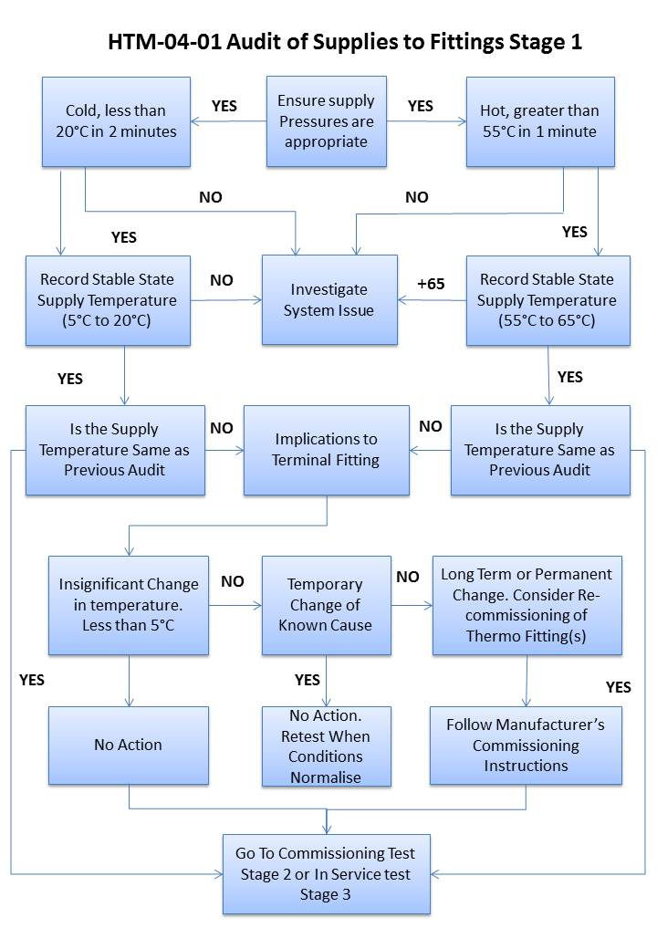

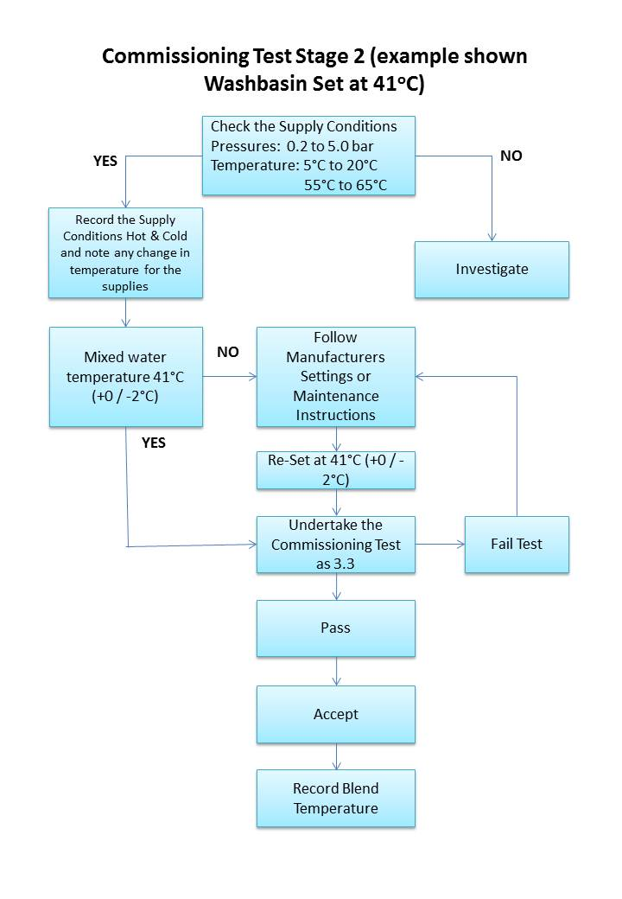
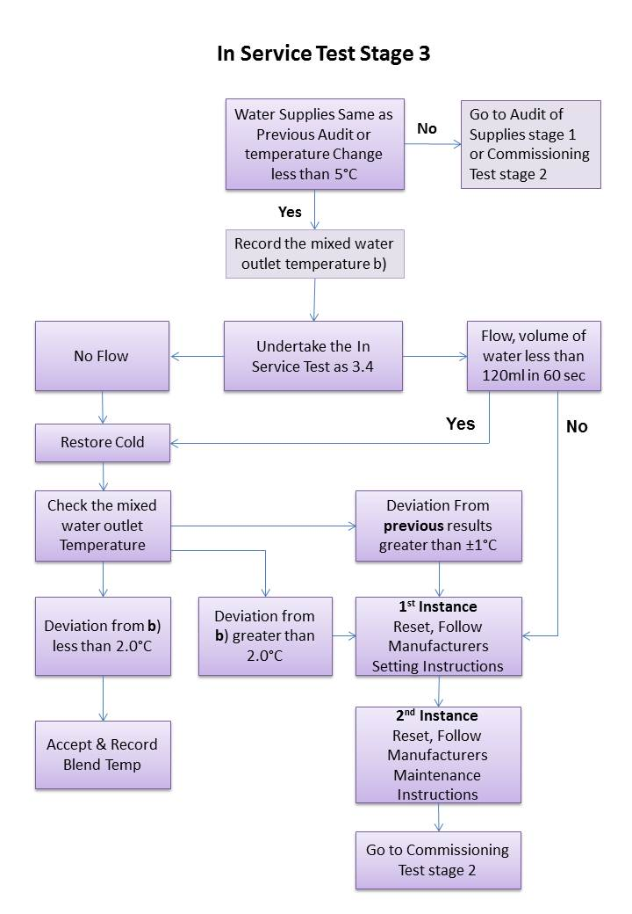

TMV TEST RECORD SHEET

Test Date:

Valve Reference |  | Location
Blend Setting |  | Installation Date
Outlet type  Bath/washbasin/shower |  | Maintenance frequency
Min temp diff for the valve |  | Maintenance frequency
Engineers name: |  | Maintenance date:

SUPPLY CONDITIONS
Date | Previous supply conditions | Service Detail | Current supply conditions
 |  | Hot Supply Temp
 |  | Cold Supply Temp
 |  | Hot Supply Pressure
 |  | Cold Supply Pressure
 |  | Stable Mixed Water Temp
 |  | Temperature differential

Non Compliance with HTM-04-01: Remedial actions required are as follows

IN-SERVICE TEST RESULTS (Clause 3.4)

Test Detail | Result | Observation/comment
Mixed Water Temperature at Maximum Flow (X) | ºC
Mixed Water Temperature at 50% Flow | ºC
Isolate cold water supply – No flow after 5s? | Yes/no
Volume of water if flow after 5s* | Yes/no  ml
Mixed Water Temperature after supply restored | ºC
Deviation from initial result X  greater than 2ºC** | ºC
Deviation from previous in-service result  Greater than 1ºC? | ºC
Strainers / Check Valves clean? | Yes/No
Isolation Valves fully open? | Yes/No
Final Mixed Water Temperature | ºC
* If volume > 120ml reset valve according to manufacturer’s instructions and retest.
** If yes then reset valve according to manufacturer’s instructions and retest.

Frequency of In-Service Test (Clause 3.5)

Next In-Service Test date

